**INTERMEDIATE DOCUMENTATION**

# Abstract

Since the knowledge of network design is increasingly popular especially in the cyber-physical systems, the use of networks in automotive industry to increase and modify vehicle features (wiper control, airbag, door lock, etc.) are realized over networked electronic components and software. These innovations are implemented by tapping in information from actuators, sensors, and ECUs via networks. Correctly applied network technologies can be used to increase comfort and safety while keeping the cost low.

Taking the low cost, longevity, safety and security in prime consideration, LIN (Local Interconnect Network) deals with sensors and actuators with very low cost of installation. As a hands-on development project, an arduino ecosystem will be demonstrated with one master node three slave nodes will exchange data via the LIN Node. Additionally, with the help of push buttons integrated on the master-slave nodes we can display LIN frame transfers on the oscilloscope.

# Introduction

LIN, Local Interconnect Network, that tries to provide everything that we need to build a simple, low-cost bus tailored to the needs of the automotive industry. It is quite unique to know that it goes beyond the standard of OSI Layer 1 and 2. Having an aim to build simple, cheap, and reliable networks with relatively low-cost components. LIN is widely popular and present in many vehicle platforms, with the usage of 20+ LIN nodes per vehicle is not an exception. Up until 2010, the specification was maintained and advanced by the LIN consortium. A consortium originated with 5 major OEMs (original equipment manufacturers) with its first release of specification, LIN 1.0, in 1999. The consortium was disbanded on 31st December 2010 with its release of last LIN official consortium of version 2.2.A. This specification is considered stable and was transcribed and made available to the International Organization for Standardization (ISO). Later, ISO updated the specification in 2016, partitioned it out into multiple documents and made the documents available under the ISO 17987 Part 1-7.

While LIN is more than OSI layer 1 and 2, main interests surround around the characterization of LIN Network. Since it aims at cost efficient, small sensor, actuators, and control networks. It is widely used where bandwidth is not the main criteria rather low-cost and accessibility. LIN is a serial byte-oriented network protocol, the smallest data unit to be transferred is one byte. We can run LIN on very low-cost ECUs. Theoretically, even without a quartz clock but only with an RC element. Moreover, the single wire connectivity intends to cater up to 40m length and can transmit up to 20Kb/s with a required operation voltage of 12V. The OSI layer 2 specifies a shared multiplexed communication, where all the participants share the single wire. The architecture is a master-slave setup with up to 16 nodes, one master and up to 15 slave nodes. Furthermore, within the time-trigger shared multiplexed communication the master initiates all network flows. The master is in control so that collisions and bus arbitration can be avoided. LIN typically supports the data size of 1-2 bytes. Plus, there is also a set of error detection measures and diagnostic support included as part of the network standard. Summing up to application areas, LIN is ideal for sensor networks used in low-cost body electronics. Typical applications are roof, door, window, seat, dashboard, airbag, climate control, engine, and steering wheel.

# State of the Art

# Bibliography

Paret - Multiplexed Networks for Embedded Systems CAN, LIN, FlexRay, Safe-by- Wire· 2007.

Richard Zurawski. Industrial Communication Technology Handbook. CRC Press, 2015.

Dominique Paret.John Wiley - Multiplexed Networks for Embedded Systems.

Sons Ltd, 2007.

Project Inspiration: Dogan Ibrahim - PIC Microcontroller Projects in C, Second Edition 2014.

LIN bus explained - A Simple Intro,

<https://www.csselectronics.com/screen/page/lin-bus-protocol-intro-basics>

# APPENDIX

Blueprint:

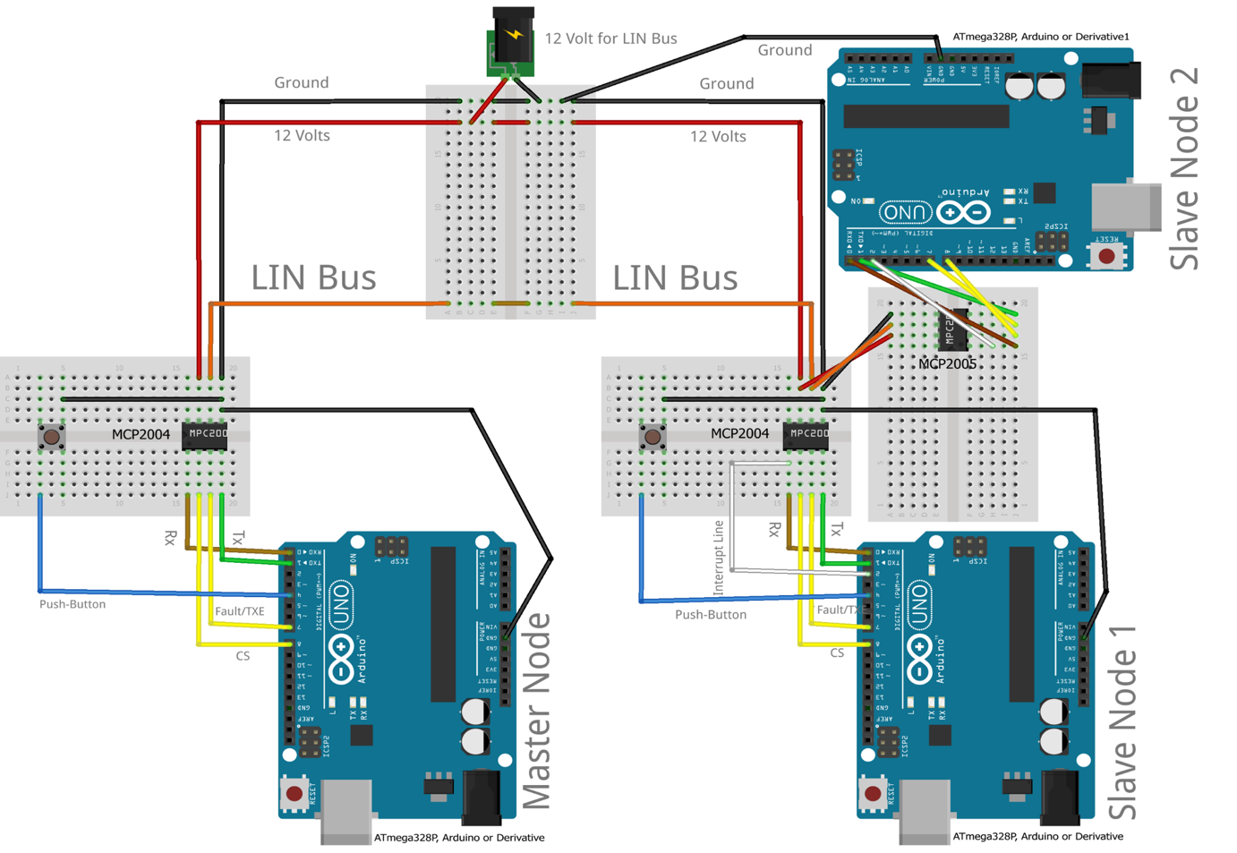

Prepared By:

Syed Rafsan Ishtiaque

Yigitcan Aydin

Muhammad Rohail Usman